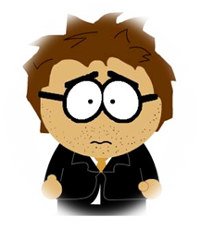
Website Testing Table
Note: If you make any changes, you must record it on the document “webs-improvement-document”
- What are you testing | - What actually happened
- How you are testing it | - What action you took to solve the problem
- What you expect to happen | - Test links, multimedia, readability and use peer review!

WHAT IS BEING TESTED | HOW IS THIS ELEMENT TESTED? | EXPECTED OUTCOME | ACTUAL OUTCOME | ACTION TAKEN
(1). In register page, when user don’t enter any details there should be pop up window to say you must need to fill this field.  (2). Register Page. (Alert window it says JavaScript alert, which we want to change as Inox Cinema Page says: ) | By running HTML code.  By running HTML code. | For Example: in register page if user don’t enter his first and last name it should display both error Like please enter your First Name and Last Name.  Instead of JavaScript Alert it should display Inox Cinema page says. | It’s giving error one by one not together.  Current Outcome:  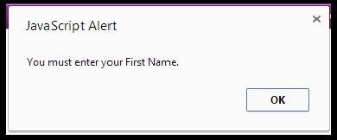  Current Outcome:  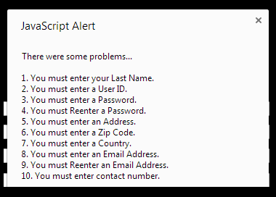 | So I use if else statement and error.push method to alert user about field which are empty. After making changes all error codes are coming in one alert window, in (2) you can see that image.  Still doing research on how to change that.
(3). Login section | By logging in on login page. (By running HTML code.) | Only member can login. | If you put any user id and password it take you to the home page of the website. | Still working on database and php file, so I can create the separate login page for the members.
(4). Home page (Trailers of new movies on front page). | Location of flash player was not right. | 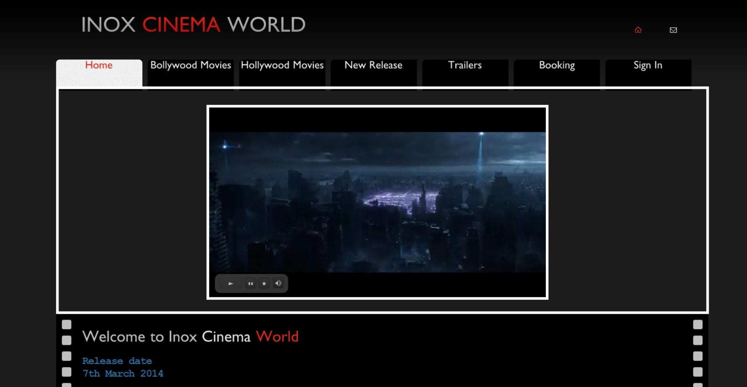 | It show only left side not where I wanted to set. | It’s working fine after
(5). Booking page (). | Work on validation with  Database but get some  Difficulty to make connection |  | Linking is not working properly | Work on linking
(6).

WHAT IS BEING TESTED | HOW IS THIS ELEMENT TESTED? | EXPECTED OUTCOME | ACTUAL OUTCOME | ACTION TAKEN

